Name \_\_\_\_\_\_\_\_\_\_\_\_\_\_\_\_\_\_\_\_\_\_\_\_\_\_\_\_\_\_ HOMEWORK Sept. 19-23

Put your initials by each night that your child practiced the following:

\_\_\_\_ Monday \_\_\_\_Tuesday \_\_\_\_Thursday

**\*Nightly Homework\***

1. Count numbers 1-25.

2. Practice letter name and sounds.

**Monday-**Say the word, count the syllables, and color the number of syllables you hear.

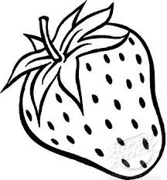

strawberry

4

3

2

1

**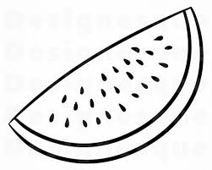**

watermelon

4

****

rainbow

1

3

2

4

3

2

1

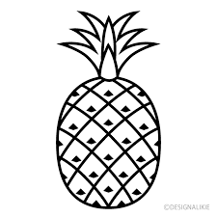

pineapple



sunflower

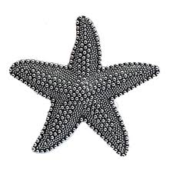

starfish

4

3

2

4

3

2

1

1

2

3

4

1

Say the word. Color the picture that ends with the sound /t/.

|  |  |  |
| --- | --- | --- |
| /var/folders/q_/_fcz5trx6lgbymd1bcc0qzsc0000gn/T/com.microsoft.Word/Content.MSO/534482F0.tmp  cat | Top 10 Baseball Bat Clipart Black And White Library Vector Drawing Pictures  bat | /var/folders/q_/_fcz5trx6lgbymd1bcc0qzsc0000gn/T/com.microsoft.Word/Content.MSO/15FF873C.tmp  pig |
| /var/folders/q_/_fcz5trx6lgbymd1bcc0qzsc0000gn/T/com.microsoft.Word/Content.MSO/B5811814.tmp  goat | /var/folders/q_/_fcz5trx6lgbymd1bcc0qzsc0000gn/T/com.microsoft.Word/Content.MSO/D6B98A48.tmp  duck | /var/folders/q_/_fcz5trx6lgbymd1bcc0qzsc0000gn/T/com.microsoft.Word/Content.MSO/A73F9A7C.tmp  mouse |

**TUESDAY-** Read it. Trace it. Write it.

by by \_\_\_

my my \_\_\_

to to \_\_\_

**Say the word. Color the picture that ends with the sound /b/.**

|  |  |  |
| --- | --- | --- |
| /var/folders/q_/_fcz5trx6lgbymd1bcc0qzsc0000gn/T/com.microsoft.Word/Content.MSO/50198E5B.tmp  bib | /var/folders/q_/_fcz5trx6lgbymd1bcc0qzsc0000gn/T/com.microsoft.Word/Content.MSO/61091421.tmp  tub | Gum Art | Let Kids Chew Gum in School | Publish with Glogster! | Gumball  machine, Bubble gum machine, Heart coloring pages  gum |
| /var/folders/q_/_fcz5trx6lgbymd1bcc0qzsc0000gn/T/com.microsoft.Word/Content.MSO/4FC04CDE.tmp  bus | /var/folders/q_/_fcz5trx6lgbymd1bcc0qzsc0000gn/T/com.microsoft.Word/Content.MSO/9DEBB9F8.tmp  cab | /var/folders/q_/_fcz5trx6lgbymd1bcc0qzsc0000gn/T/com.microsoft.Word/Content.MSO/EDCC4AC6.tmp  web |

**THURSDAY-** Name the picture. Write the beginning letter for each word.

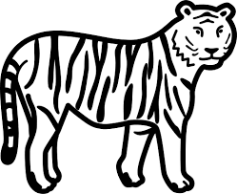\_ **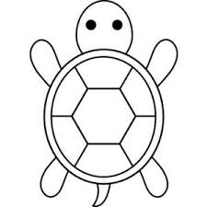**\_ **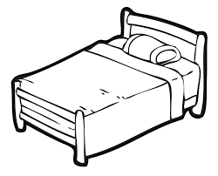**\_

\_ \_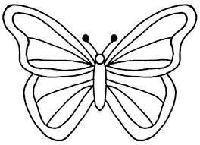\_

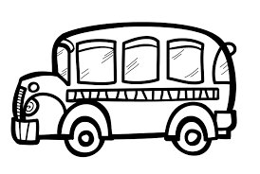

Star Right Reader Week of Sept. 19-23

(Please let your child read this to you.)

Words to know

by to my

**See my boat? **

**See the bird 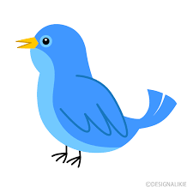by the boat! **

**See the bird by my bike. 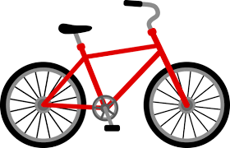**

**See the bird by the bush. **

**See the bird  by the bush. **

**Run  to the bush! **

**See my boat! **